**Data Visualization using PowerBI  
COVID-19 Global Data Analysis**  
  
Page 1  
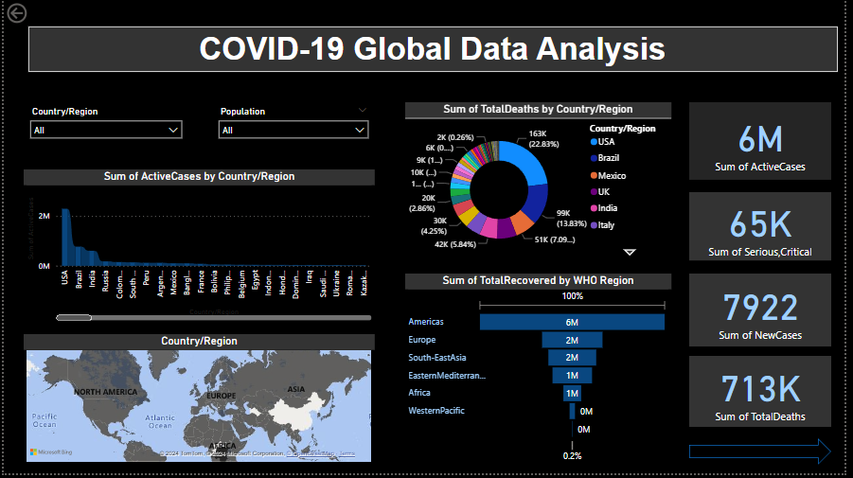  
  
Page 2  
  
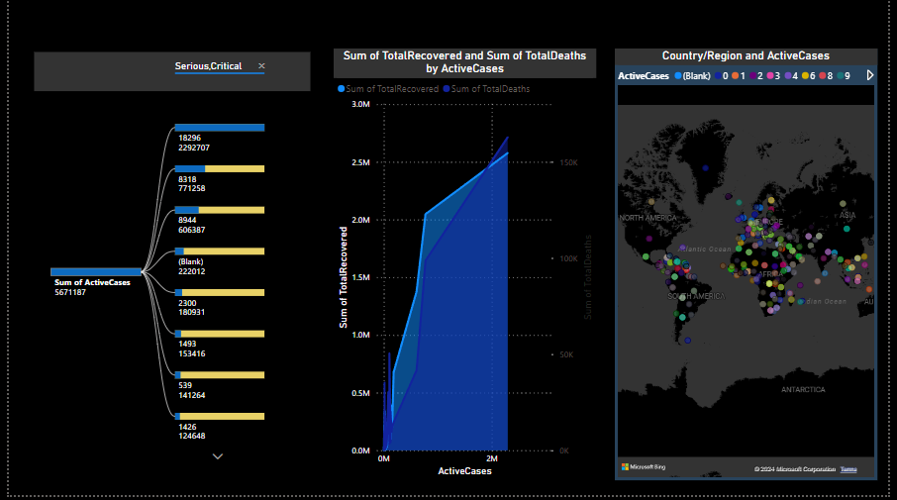  
Page 3  
